28.Design DFA using simulator to accept the string the end with ab over set {a,b)

W= abbaabab

*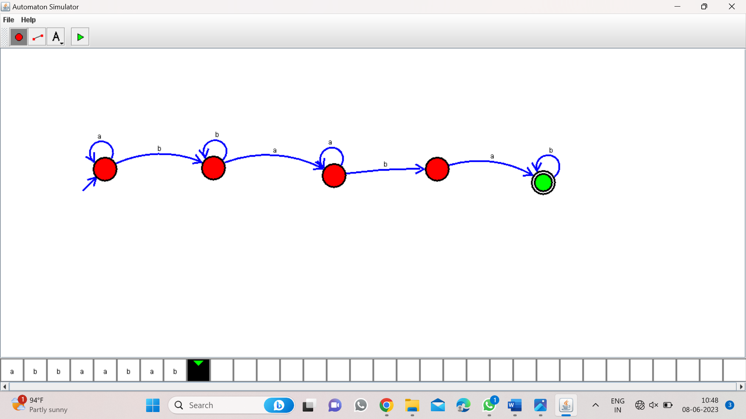*

Result:-

Fram the DFA Diagram valid the input string abbaabab